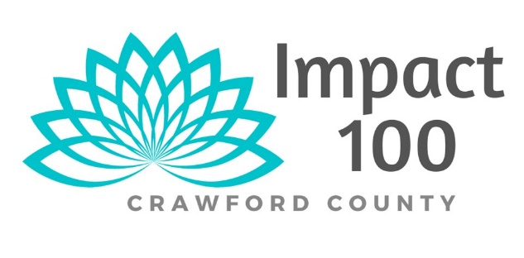
“Friend” enrollment form
By becoming a friend of Impact 100 Crawford County, you are helping a community of women united in a common cause --to provide high-impact grants (we are talking $5,000 to $10,000 or more) to exceptional nonprofit organizations serving Crawford County, Missouri. All your money goes toward the administrative costs of Impact 100 Crawford County to ensure that 100% of the Member’s proceeds go to the nonprofits.

But also as a friend you will . . .
- Have a chance to help an effort that will have a transformative impact on your community.
- Become a “friend” to a group that will control how all proceeds are distributed. Every member has a vote. (Friends do not vote)
- Become part of a like-minded group seeking to enrich our community in a meaningful and sustainable way.
- Participate in the giving process; learn about the specific areas of need within our community and how nonprofit groups are working to meet these needs.
- Help provide the means for the women to have their annual membership meeting/celebration in September of every year.
Please select one of the friend options:
- $500 tax-deductible donation
- $250 tax-deductible donation
- $100 tax-deductible donation

(All the above monies will fund operating expenses and the annual membership meeting/celebration in September)

To become a “friend” of Impact 100, please write your tax-deductible donation check made payable to Impact 100 Crawford County and mail it with this form to Impact 100 Crawford County, P.O. Box 61, Cuba, MO 65453.

If you have further questions, contact Kathy Lasley at lasleydk@gmail.com, Cell: 573-205-0345.

Name

Address

Best Contact Phone #

Email

